RESUME
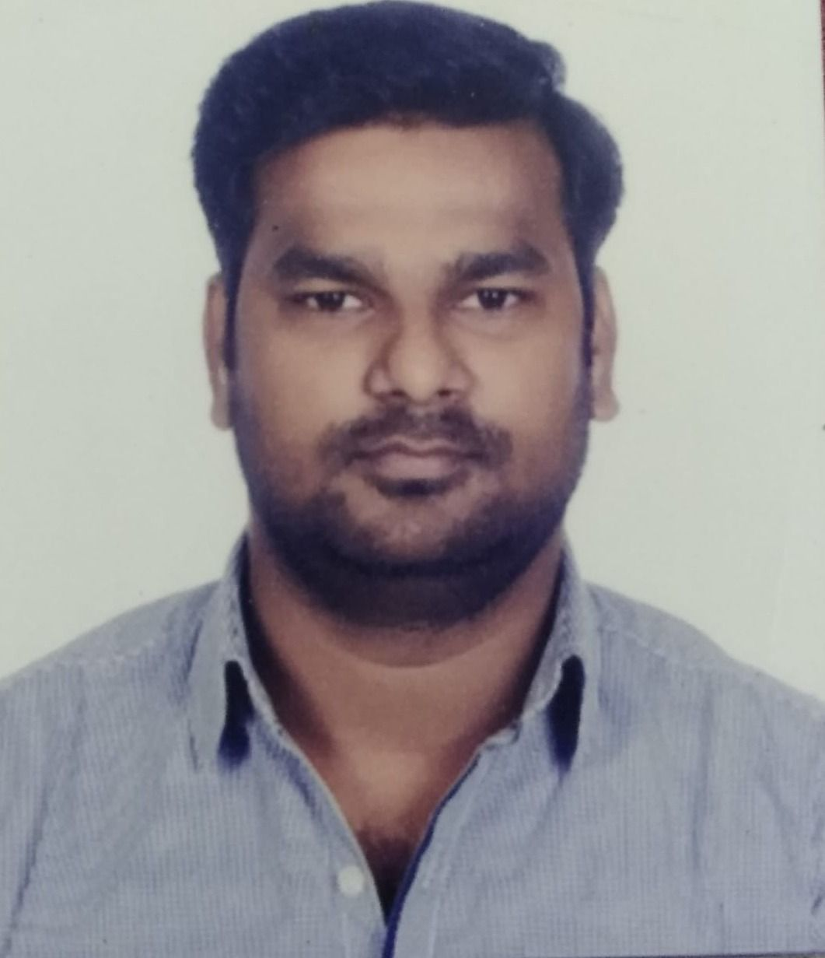ffix latest color photograph
(Blue or White Backgr ound)

Employee Name : Amit Singh Rathore

Date of Birth : 29th June 1987

Email Id : amitsinghrathore29@gmail.com

Address : Plot No. 49-E Guru Sampada Apartment Flat No.102

Near BCM Paradise Tulsi Nagar Indore 425010

Mobile No. - : +91-9713668743, 9039968743

CAREER OBJECTIVE: - Seeking a challenging career where I will utilize my inherent capabilities, enhance my skills and strengths in conjunction with the organization's goals and objectives and thus to prove myself a worthy asset for the organization with showing effectiveness by taking risk in new venture.
EDUCATIONAL QUALIFICATION: -
*Bachelor of engineering (Electronics and Communication).
*Currently Doing Certifications on Cloud (Dockers & Kubernet).
Experience Summary: - Around 12+ Years’ experience in Telecom in various roles Fiber /MW/RF/IP Networking/ Quality Management.
- Integration, Project Roll-out in DRAIPL /Bharti Airtel/Samsung Networks/Ceragon/Wipro.
- Co-ordination, Documentation, Quality audit, WH Management, Managing Vendors, and Building Customer Relation.
- Project - Supervision, Team handling, Installation, Site survey, RF survey, Commissioning and testing.
- Strong relationship management skills, ability to network with project members / vendors with consummate ease.
STRENGTHS: -
- Confident hard worker & valued team player with excellent communication skills.
- Quick learner & Implementer.
- Flexible to work & perform in pressurize situations.
- Excellent Ability to deals with clients and customers.
- Interested to prove excellent in all activities by commitments.
- An effective and innovative team controller.

Summary of Work Experience
(Start with current employer)

Name of Employer : Dineshchandra R Agrawal Infracon Pvt. Ltd. (DRAIPL)
Dates of Employment : May 2023 to till Date.
Job Title : Project Lead in MP & Rajasthan Circle.

Project Description : NHAI OFC Project (Bharat Mala Project).

Role : Deputy Manager MP & Rajasthan Circle

Responsibilities:
- Work as a Project Deputy Manager in MP & Rajasthan Circle.
- 9 Months Experience in overseas OFC project in DRAIPL.
- Quality check fiber route done with Deployment Team & Partner team.
- Coordinating with customer’s NHAI team to ascertain their requirements which helps them in their future rollout.
- 355KM UG Work in progress at Delhi Mumbai New Expressway.

Name of Employer : Bharti Airtel Limited
Dates of Employment : Dec -2020 to May 2023
Job Title : FTTH Auditor & AT.

Project Description : FTTH Project.

Role : Auditor & AT

Responsibilities:
- Work as a Field AT & Auditor MP Circle.
- 29 Months Experience in overseas fiber project Bharti Airtel Limited.
- Quality check fiber Overhead route done with Deployment Team & Partner team.
- Currently I have Done 557 ODF RFS done in OSP Work with WCR Closer.
- 880KM UG Work Audit & AT Done & Handover to O&M.
- Dedicated and safety-conscious professional with a strong background in safety protocols and procedures.
- Seeking a field Auditor role where I can apply my expertise to ensure a secure work environment and contribute to the overall safety of the organization.

Name of Employer : Bharti Airtel Limited
Dates of Employment : Jun -2018 to Nov - 2020
Job Title : Project Engineer OFC Project

Project Description : BBNL Project, Airtel Junoon LTE Project.

Role : Network Rollout Engineer

Responsibilities:
- Work as a team leader.
- 2.4 Year Experience in overseas fiber project Bharti Airtel Limited.
- Construction Quality check fiber route done with vendor team.
- In 2.4 years I have 269 LM Nodes & 536km IP1 (DEPL Route) & 97Km Airtel Own BB Route & 236Km IRU Route (Tata, Vodafone, Idea) Route delivered on time.
- Currently I have Done 1286Km BB Route Survey done for new OSP Work.
- AT offer to Quality team & complete AT Without NC & handover to operation team.
- Installation & Commissioning Mux (ECI & Huawei) & FDMS.
- Making OWN & IRU Route surveys with much economy and feasibility,
- Dealing with Prime Vendors & Sub Vendors & ROW Authority (NHAI, PWD, Gram Panchaayat, Nagar Parishad, Zila Parishad ,Nagar Palika)
- Managing of All working teams to give speed with quality.
- 639Km Quality Patches completed without NC point & Handover to O&M Team.
- Fiber rectification through OTDR from both ends & Fiber Loss rectification through OTDR.
- Having Complete Knowledge on Optical Fiber laying both in Backbone and Access networks, as well as Micro ducting and Micro cabling,
- Responsible for Implementation, development, Operation & maintenance of entire fiber, transmission electrical, mechanical & civil Infrastructure.
- Recognized for speed and precision in cutting, splicing, and installing cable while still staying within the limits of safety protocols.

Technologies:
- 2G & 3G & 4G.
- ECI (1050 & 1050i & 1200 & 1200i) & Huawei & Ciena equipment (MUX) I&C Done.
- Operate OTDR & Splicing Machine as par requirements.

Name of Employer : Samsung Electronics (India) Pvt. Ltd
Dates of Employment : Feb -2015 to May-2018
Job Title : LSMR & Integration & Coordinator

Project Description : Reliance Jio LTE Project

Role : LSMR & Integration Engineer (SME)

Responsibilities:

- Work as a team leader.
- 39 month Experience in overseas project (RJIO) in Samsung Electronics (India) Pvt. Ltd. (Samsung eNodeB & Ceragon MW & OFC Work).
- Testing, commissioning and maintenance of IP-20C (PDH/SDH) (8Month Up gradation of new version of CDU ,RDU & RRH software & transmission cards.
- Ceragon Microwave Technical Support to Field Engineer (8 Month).
- Installation, testing, commissioning and maintenance of Samsung eNodeB & Ceragon Microwave Antennas.
- Expertise in troubleshooting of Samsung CDU/ RDU & Ceragon Microwave Antenna equipment(6Month).
- Alarm Clear at onsite by LSMR & performance of ATP11B .
- 850MHz and Swapping of 2300MHz and 1800MHz Roll out Installation of 7100 sites with all closure of ATP 11A and ATP 11B.
- Look out quality installation of 2300MHz/1800MHz/850MHz Band 4G Antenna and swapping of 2300MHz,1800MHz,850MHz Band 4G Antenna to Multi Band/ Penta Band 4G Antenna.
- After Installation of Sites ATP 11A and ATP 11B Task performed through Site Forge and Net Velocity Apps.
- ATP 11B considered Volte Call Testing for each Sectors and Throughput Testing with the help of Net Velocity App.
- ATP 11A considered all installation snaps with proper quality done.
- Proactive maintenance of Network through planned outages in co-ordination with the field Team. Exposure to Implementation, Commissioning of EnodeB, Throughput Testing and traffic routing.
- Fault Analysis, Alarm Clearance, Corrective and Preventive action to reduce fault rate and improve network availability.
- Performing various technical activities to make ENodeB reachable to SGW/MME, software up gradation of EnodeB.
- Provided support of RF team for Golden Parameter.
- Provided technical support to O&M team to restore eNodeB.

Technologies:
- 4G RJIO (2.3GHz ,1.8GHz ,850MHz).
- Samsung equipment (CDU & RDU &RRH & eNodeB) technically Support as SME.
- Ceragon Microwave Team Technically Support as SME.

Name of Employer : Ceragon Networks (India) Pvt. Ltd
Dates of Employment : March -2014 to Feb-2015
Job Title : Project coordinator

Project Description : Reliance Jio LTE Project

Role : Project Coordinator

Responsibilities:

- Work as a team leader.
- 12th month Experience in overseas project in Ceragon Network (India) Pvt. Ltd.
- Up gradation of new version of IDU software & transmission cards.
- Installation, testing, commissioning and maintenance of IP-20N and IP-20C (PDH/SDH).
- Expertise in troubleshooting of Ceragon M/W SDH equipment.
- Expertise in different configuration 1+0,2+0 equipment.
- Coordinate system layout engineering staff.
- Perform telecommunications analysis and develop appropriate system concepts and layouts.
- Perform site visits for documentation of existing systems.
- Maintaining SDH transmission CERAGON links.
- Performed activities of bringing transmission of node sites from PDH to SDH.
- Give technical support to field executive for Microwave Links.
- Interact with NEO team & Back office team to convert Microwave Link vice versa.
- Interact with IP planning team to cross check IP in DHCP.

Technologies:
- 2G,3G,4G,
- Ceragon equipment (IP-10,IP-20N,IP-20C)
Name of Employer : Wipro Technology Ltd.
Dates of Employment : May-2012 – March 2014
Job Title : Project Engineer

Project Description : NSN- Bharti, Vodafone, Tata.

Role : Project Engineer

Responsibilities:
- Responsible for onsite assignments for domestic projects.
- Handle responsibilities of installing and configuring Microwave Antennas.
- Perform the tasks of troubleshooting reported installation issues
- Perform ‘AT’ as well as functional testing on a regular basis to ensure system operations.
- Handle responsibilities of installing and configuring Huawei BTS & NEC Microwave at TATA Project.

Technologies:
- 2G,3G
- Nokia BTS ,Huawei BTS ,NEC ,Ceragon IP10,Huawei RTN 910, 950.

Name of Employer : Advanced communication tele Infratech Technology
Dates of Employment : May 2011 - April 2012
Job Title : I&C Engineer

Project Description : Airtel, Vodafone

Role : I&C Engineer

Responsibilities : Installation & commissioning MW

Technologies:
- 2G,3G
- Alcatel lucent BTS,NEO SDH/PDH/I-PASO.

Software & Tool Skills:
- Operating System: Windows ME/ NT/98/MS DOS.
- Self Confidence & Motivational attitude.
- Training Courses
- SIM Based Meter
- Digital Telephone Amplifier

Personal Profile:
Father Name : Sh. M.P Singh Rathore
Date of Birth : 29-06-1987
Sex : Male
Nationality : Indian
Language : Hindi, English
Marital Status : Married
Hobbies : Sports, Cooking.

Declaration: I assure that all the information given above is true to the best of my knowledge and record. I will deliver my best if given an opportunity.

DATE:
Amit Singh Rathore
PLACE: Indore SIGNATURE OF EMPLOYEE

